**Design Principles and Patterns**

**Exercise 1: Implementing the Singleton Pattern**

class Logger {

private static Logger instance;

private Logger() {

System.out.println("Logger instance created.");

}

public static Logger getInstance() {

if (instance == null) {

instance = new Logger();

}

return instance;

}

public void log(String message) {

System.out.println("Log: " + message);

}

}

public class Main {

public static void main(String[] args) {

Logger logger1 = Logger.getInstance();

logger1.log("Application started");

Logger logger2 = Logger.getInstance();

logger2.log("Application running");

if (logger1 == logger2) {

System.out.println("Both logger1 and logger2 are the same instance.");

} else {

System.out.println("Different instances exist!");

}

}

}

**Output:**

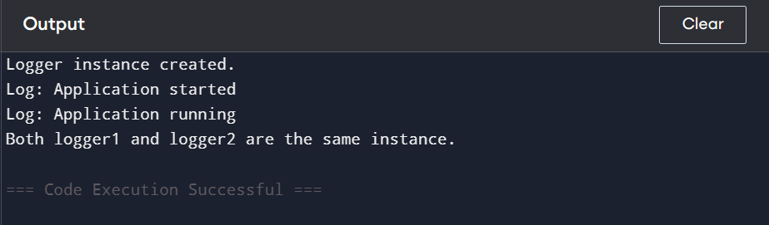

**Exercise 2: Implementing the Factory Method Pattern**}

// File: Main.java

// Step 2: Document Interface

interface Document {

void open();

}

// Step 3: Concrete Document Classes

class WordDocument implements Document {

public void open() {

System.out.println("Opening Word document...");

}

}

class PdfDocument implements Document {

public void open() {

System.out.println("Opening PDF document...");

}

}

class ExcelDocument implements Document {

public void open() {

System.out.println("Opening Excel document...");

}

}

// Step 4: Abstract Factory Class

abstract class DocumentFactory {

public abstract Document createDocument();

}

// Step 4 (continued): Concrete Factories

class WordDocumentFactory extends DocumentFactory {

public Document createDocument() {

return new WordDocument();

}

}

class PdfDocumentFactory extends DocumentFactory {

public Document createDocument() {

return new PdfDocument();

}

}

class ExcelDocumentFactory extends DocumentFactory {

public Document createDocument() {

return new ExcelDocument();

}

}

// Step 5: Test Class

public class Main {

public static void main(String[] args) {

DocumentFactory wordFactory = new WordDocumentFactory();

Document wordDoc = wordFactory.createDocument();

wordDoc.open();

DocumentFactory pdfFactory = new PdfDocumentFactory();

Document pdfDoc = pdfFactory.createDocument();

pdfDoc.open();

DocumentFactory excelFactory = new ExcelDocumentFactory();

Document excelDoc = excelFactory.createDocument();

excelDoc.open();

}

}

**Output :**

